

**Addis Ababa University**

**Addis Ababa Institute of Technology**

**School of Electrical and Computer Engineering**

**Digital Hearing Aid**

A Semester Project submitted to

School of Electrical and Computer Engineering Addis

Ababa Institute of Technology

By: Fraol Bereket

Henok Hailu

Advisors’ Name: Melake Serawit

Date of submission: Feb 14, 2022

**Abstract**

In Ethiopia up to one million persons with hearing impaired live across the country. In this project, we will be building a Digital hearing aid. The goal is to build a low power, cost-effective digital hearing aid that has several key intelligent features. And there is low accessibility to get the hearing aid device. By dealing with the association of hearing disorder committee we will go forward to provide this device to the intended peoples. On our project, in the phase one, we are going to make the simulation, the initial system design and other things which helps us to develop the final system design and make ready to the implementing and testing. There will be a complete design for the device at the end of this project. This project will help the hearing impairments by making their life easier than before.

Table of Contents

Introduction 3

Background 3

Problem Statement 4

Project scope and limitations 5

Objective 6

Literature Review 7

Types of hearing loss 7

Types of hearing aids 7

Body Worn 7

Behind the Ear Hearing Aids (BTE) 8

In the Ear Hearing Aids (ITE) 9

In the Canal (ITC) 10

Analog and Digital hearing aids 11

Analog hearing aids 11

Digital hearing aids 11

Theoretical Background 12

Present Curative Measures 13

Methodology 14

Microphones 14

Amplifiers 14

Filters 14

Analog to Digital Converter 16

Microcontrollers 16

Digital to analog Converter 17

Software Implementation 18

Result 21

Remaining Work 21

References 22

# Introduction

## Background

The ear is one of the most needed organs of our day-to-day life. When something happens to the ear, we immediately need a solution. The ear is the organ that enables hearing and balance. The ear is usually described as having three parts—the outer ear, the middle ear and the inner ear.

A person is said to have hearing loss if they are not able to hear as well as someone with normal hearing, meaning hearing thresholds of 20 dB or better in both ears. It can be mild, moderate, moderately severe, severe or profound, and can affect one or both ears. Major causes of hearing loss include congenital or early onset childhood hearing loss, chronic middle ear infections, noise-induced hearing loss, age-related hearing loss, and ototoxic drugs that damage the inner ear. [1]

A person is said to have hearing loss if they are not able to hear as well as someone with normal hearing, meaning hearing thresholds of 20 dB or better in both ears. It can be mild, moderate, moderately severe, severe or profound, and can affect one or both ears. Major causes of hearing loss include congenital or early onset childhood hearing loss, chronic middle ear infections, noise-induced hearing loss, age-related hearing loss, and ototoxic drugs that damage the inner ear.

Currently more than 1.5 billion people (nearly 20% of the global population) live with hearing loss. 430 million of them have disabling hearing loss. It is expected that by 2050, there could be over 700 million people with disabling hearing loss. [1] Significant number of people with hearing loss live in low- and middle-income countries. Accessibility to an affordable hearing aid is critically low. The purpose of this project is to design and simulate a digital hearing aid using affordable micro controllers.

A hearing aid is an electronic device used to improve hearing by amplifying sound to a person with hearing loss. It receives sound through a microphone, amplifies it, changes it into digital signal, processes this digital signal, and finally converts the signal back to analogy sound, this time amplified and noise filtered.

In this project, digital hearing aid, we will provide a digital hearing device that has many features. It enables hearing disorder people to hear a clear and noiseless sound with their requirements (amount of dB). The device converts the analogue sound to digital then filters and after that it converts to analogy.

## Problem Statement

The World Health Organization’s (WHO) survey report shows that around the world there are over 430 million people who have hearing loss. And in less than 30 years, nearly 2.5 billion people globally face a hearing loss problem. [1]

The average cost of one digital hearing aid can range from $1,000 to $4,000. The cheapest hearing aids cost between $1,500 to $3,000. Midrange hearing aids cost from $3,000 to $4,500. Premium hearing aids fall in the range of $4,500 to $6,000 per device. [2]

Significant number of people with hearing loss live in low- and middle-income countries. Accessibility to an affordable hearing aid is critically low in these regions. This issue motivates us to do our research in hearing aid devices.

## Project scope and limitations

In our Hearing Aid project, we intend to implement the hearing device in a small electronic device that has a gain controller and a frequency controller. We try to pick the best electronic devices based on the features it has and cost wise.  And the Hearing Aid device will have a feature of hearing enhancement and a noise reduction. Based on the time it takes to implement these features, we will try to add a feedback suppression and wind suppression.

The limitations we face are

* The cost of the materials we use.
* The size of the device. New hearing aids are so tiny that you can’t even see them, but our product size is larger compared to the modern ones.
* Comfort while wearing it, we will try as much as we can to make it comfortable for the users.

## Objective

General Objective

The project general objective is to develop a system that takes any analog sound as an input and it processes the input and gives clear sound using a digital sound processing and a microcontroller concept.

Specific Objective

Our specific objective is to implement our system to a wearable device that assists hearing disorder people to have better social interactions and ease of communication and provide a Digital Hearing Aid with a reasonable price and less power conception. This benefits the people by improving the verbal communication with others. Our project supports a tuning feature that provide the user of the device to modify the sound with his/her ability of hearing.

# Literature Review

Hearing aids are devices used by hearing impaired people to compensate hearing losses. It receives sound through a microphone, amplifies it, changes it into digital signal, processes this digital signal, and finally converts the signal back to analog sound, this time amplified and noise filtered.

## Types of hearing loss

The two main categories of hearing losses are conductive and sensor neural. Hearing loss can also be attributed to a combination of both types, a mixed hearing loss.

Conductive hearing loss is caused by any obstruction that prevents sound waves from reaching the inner ear. Some of the causes of conductive hearing loss can include: An accumulation of earwax, a collection of fluid in the middle ear or due to Middle ear infections.

Sensor neural hearing loss refers to problems in the cochlea or the auditory nerve. Most are due to deterioration of the tiny inner or outer hair cells. This accounts for 90% of permanent hearing losses and although it may be a natural part of aging other causes can include due to Head injury, certain medical treatments such as chemo- and radiation therapy, Genetic predisposition, Sensor neural hearing losses cannot currently be corrected medically. It is quite possible for a conductive hearing loss to occur together with a sensor neural hearing loss. When this occurs, the hearing loss is referred to as a mixed hearing loss.

Noise-induced hearing loss, a common cause of hearing loss is caused through prolonged exposure to harmful sound (noise) or a sudden brief but intense noise like an explosion to the ear. The nature of noise-induced hearing loss is sensor neural, and at present, can only be helped and not cured.

Hearing aids differ by:

* design
* technology used to achieve amplification (i.e., analog vs. digital)
* special features

## Types of hearing aids

### Body Worn

It is the earliest form of portable hearing aids. It has 2 basic components: an Ear-mold and a case.

Provide higher gain and have better handling of acoustic feedback. The problem with this type is the size of the material.

### Behind the Ear Hearing Aids (BTE)

The body of a BTE hearing aid sits behind the ear. It is usually held in place by hooking over the top part of your ear, via which a thin plastic tube connected to an earmold or receiver fits into your ear canal. [3]

BTE hearing aids are suitable for mild to severe or profound hearing loss, and the design of the receiver allows ambient sound to pass into the ear naturally, improving the overall sound quality.

BTE hearing aids with earmolds are better at delivering sound and are suitable for people with low to high-frequency hearing loss. 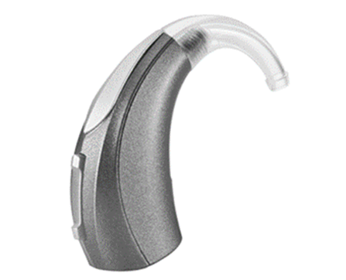fig 1. Behind the ear

Pros:

* Provide great sound quality
* Suitable for people with low-frequency hearing loss
* Comfortable fit and design
* Reduces the occurrence of feedback loops

Cons:

* It may be difficult to get used to
* Earmolds may need to be adjusted as your ear shape changes
* May cause earwax build-up
* If not correctly fitted, it can make your voice sound too loud

### In the Ear Hearing Aids (ITE)

ITE hearing aids fit entirely inside your ear, typically with only a part of it visible in your outer ear. In the ear hearing aids usually come with directional microphones and can treat mild to severe hearing loss, although the devices are often more prone to damage from ear wax.

In the ear (ITE), hearing aids can fit in the canal or slightly protrude from the outer ear and are less noticeable than behind the ear versions.

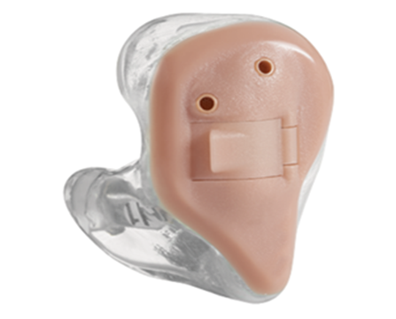fig 2. In the ear

Pros:

* The larger size means more functions and longer battery life
* Easy to insert and remove
* Can use directional microphones

Cons:

* More noticeable than other ITE styles
* It can feel like it’s blocking your ear

## In the Canal (ITC)

In the ear canal (ITC) hearing aids are true to their name and sit somewhat protruding into your ear canal, with part of it visible in your outer ear.

ITC hearing aids are suitable for treating mild to moderate hearing loss and often come with directional microphones to improve sound clarity and quality. In-the-canal aids are also less noticeable than low-profile or behind-the-ear hearing aids.

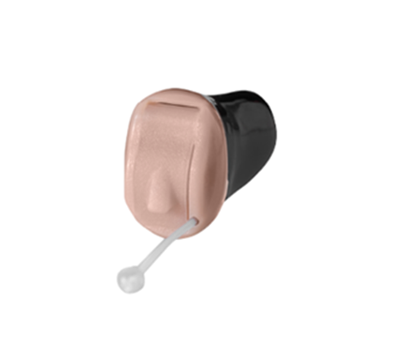fig 3 in the canal

Pros:

* Discreet and relatively unnoticeable
* It can still be controlled manually
* Better battery life than many other ITC devices

Cons:

* Aren’t suitable for profound hearing loss
* Can cause wax or moisture build-up

## Analog and Digital hearing aids

### Analog hearing aids

Analog hearing aids make continuous sound waves louder. These hearing aids essentially amplify all sounds (e.g., speech and noise) in the same way. Some analog hearing aids are programmable. They have a microchip which allows the aid to have settings programmed for different listening environments, such as in a quiet place, like at a library, or in a noisy place like in a restaurant, or in a large area like a soccer field. The analog programmable hearing aids can store multiple programs for the various environments. [4]

As the listening environment changes, hearing aid settings may be changed by pushing a button on the hearing aid. Analog hearing aids are becoming less and less common.

### Digital hearing aids

Digital hearing aids have all the features of analog programmable aids, but they convert sound waves into digital signals and produce an exact duplication of sound. Computer chips in digital hearing aids analyse speech and other environmental sounds. The digital hearing aids allow for more complex processing of sound during the amplification process which may improve their performance in certain situations (for example, background noise and whistle reduction). They also have greater flexibility in hearing aid programming so that the sound they transmit can be matched to the needs for a specific pattern of hearing loss. Digital hearing aids also provide multiple program memories. Most individuals who seek hearing help are offered a choice of only digital technology these days.

# Theoretical Background

The audible frequency range for human ears is 20 Hz to 20 kHz and human hearing is most sensitive in the range of 1 kHz to 4 kHz. Hearing is measured in decibels. In all frequencies 0 to 20 dB is the normal hearing range. To identify the hearing loss pattern, technical researches have been conducted and conclude some plots, like spectrograms and other is audiogram. With the help of Audiogram, hearing can be plot on graph or in other words audiogram may define as, a graph that shows the audible threshold for standardized frequencies as measured by an audiometer.

At the end of a hearing test, hearing levels decide the degree of hearing loss. Hearing loss is measured in decibels hearing level (dB). If person can hear sounds across a range of frequencies at -10 dB-20dB it a will considered as having normal hearing.

|  |  |
| --- | --- |
| Classification Hearing Loss | Hearing Level |
| Normal Hearing | -10db to 26db |
| Mild Hearing Loss | 27db to 40 dB |
| Moderate Hearing Loss | 40 dB to 70 dB |
| Severe Hearing Loss | 70 dB to 90 dB |
| Profound Hearing Loss | Greater than 90 dB |

## Present Curative Measures

Presently the most effective and efficient way of handling deafness is by the use of hearing aid devices. The hearing aid device is basically what brings in sound to the ear more effectively. The basic function of a hearing aid is to amplify and couple sound wave to the ear. The basic components that make up the system are:

i. The microphone

ii. Amplifier and

iii. Receiver.

Generally, the sound wave, which can also be referred as the acoustic signal is converted to electric signal. That electric signal is amplified and reconverted to acoustic energy. The microphone is the input transducer that picks up the acoustic signal and converts it to electrical signal. The Amplifier is the signal processor that does the amplification of the electrical signal. At the end, the receiver which is the output transducer, usually the earphone reconverts the amplified electrical signal into acoustic energy as before. {Assistive Technology for the Hearing-impaired, Deaf and Deafblind}

The hearing aid device is so miniaturized in such a way that it can be body worn, can be behind the ear and can be in the ear canal. These correspond to three basic types of hearing aid. Others include: contralateral routing of sound hearing aid, telephone hearing aids and group hearing aid for auditory framing and for educational institutions.

# Methodology

**Digital hearing aids** have all the features of analog programmable aids, but they convert sound waves into digital signals and produce an exact duplication of sound. [5] Computer chips in digital hearing aids analyze speech and other environmental sounds. The digital hearing aids allow for more complex processing of sound during the amplification process which may improve their performance in certain situations (for example, background noise and whistle reduction). They also have greater flexibility in hearing aid programming so that the sound they transmit can be matched to the needs for a specific pattern of hearing loss. Digital hearing aids also provide multiple program memories. Most individuals who seek hearing help are offered a choice of only digital technology these days.

Basic Components we planned to use were: Microphones, Receivers, Amplifiers, Filters, Analog to Digital Converter, Digital to Analog Converter, Microcontrollers, Power Source.

## Microphones

an instrument whereby sound waves are caused to generate or modulate an electric current usually for the purpose of transmitting or recording sound (such as speech or music). We use this device to collect the sound from the environment for further process.

## Amplifiers

An amplifier, electronic amplifier or (informally) amp is an electronic device that can increase the power of a signal (a time-varying voltage or current). It is a two-port electronic circuit that uses electric power from a power supply to increase the amplitude of a signal applied to its input terminals, producing a proportionally greater amplitude signal at its output. The amount of amplification provided by an amplifier is measured by its gain: the ratio of output voltage, current, or power to input. An amplifier is a circuit that has a power gain greater than one. [6]

## Filters

The audio filters are the electronic circuits designed to amplify or attenuate a certain range of frequency components. This helps eliminate the unwanted noise from the audio signal and improves the tone of the output audio. Filters play a major role in telecommunication and audio electronics.

Filtering is one of the main features of our project that gives the person that use the device will be able to hear a clear noiseless sound with the help of filtering feature.

Analog Input

Filter

Preliminary

Amplifier

Analog to Digital

Converter

Microprocessor

Digital to Analog

Converter

Secondary

Amplifier

Analog Output

fig 4. Flow chart of Digital hearing Aid

## Analog to Digital Converter

Almost every environmental measurable parameter is in analog form like temperature, sound, pressure, light, etc. Consider a temperature monitoring system wherein acquiring, analyzing, and processing temperature data from sensors is not possible with digital computers and processors. Therefore, this system needs an intermediate device to convert the analog temperature data into digital data in order to communicate with digital processors like microcontrollers and microprocessors. Analog to Digital Converter (ADC) is an electronic integrated circuit used to convert the analog signals such as voltages to digital or binary form consisting of 1s and 0s. Most of the ADCs take a voltage input as 0 to 10V, -5V to +5V, and correspondingly produces digital output as some sort of a binary number.

The main features of ADC are sample rate and bit resolution.

* The sample rate of an ADC is how fast an ADC can convert the signal from analog to digital.
* Bit resolution is how much accuracy can an analog to digital converter can convert the signal from analog to digital.

## Microcontrollers

Teensy 4.0

* ARM Cortex-M7 at 600 MHz
* Float point math unit, 64 & 32 bits
* 1984K Flash, 1024K RAM (512K tightly coupled), 1K EEPROM (emulated)
* Size:     3.5*1.78cm =    1.4*0.7 inch
* 40 digital input/output pins, 31 PWM output pins
* 14 analogy input pins
* 7 serial, 3 SPI, 3 I2C ports
* 2 I2S/TDM and 1 S/PDIF digital audio port
* 3 CAN Bus (1 with CAN FD)
* 32 general purpose DMA channels
* Cryptographic Acceleration & Random Number Generator
* RTC for date/time
* Programmable FlexIO
* Pixel Processing Pipeline
* Peripheral cross triggering
* Power On/Off management [7]
* it is relatively cheap ($19 for the 4.0, $13 for the audio shield) and it is designed and made in the USA, guarantying a certain level of quality.
* The problem with mc is its availability on our country.
* If we are going to use this MC, we are thinking of putting the case on the back of the neck and the device will look like this item.

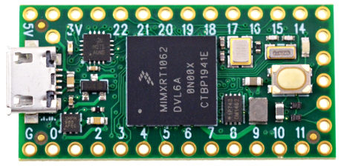

Fig 5. Teensy Microcontroller

## Digital to analog Converter

A Digital to Analog Converter (DAC) converts a digital input signal into an analog output signal. The digital signal is represented with a binary code, which is a combination of bits 0 and 1. According to the Nyquist-Shannon sampling theorem, any sampled data can be reconstructed perfectly with bandwidth and Nyquist criteria.

A DAC can reconstruct sampled data into an analog signal with precision. The digital data may be produced from a microprocessor, the data requires the conversion to an analog signal in order to interact with the real world.

## Software Implementation

The software implementation of the final project will be on a software called Teensy Duino (Teensy microcontroller software). But for now, we used Matlab, since it has a lot of features.

MATLAB (an abbreviation of "MATrix LABoratory") is a proprietary multi-paradigm programming language and numeric computing environment developed by MathWorks. MATLAB allows matrix manipulations, plotting of functions and data, implementation of algorithms, creation of user interfaces, and interfacing with programs written in other languages. [8]

We analysed the audio signals using FFT (fast Fourier transform). A fast Fourier transform (FFT) is an algorithm that computes the discrete Fourier transform (DFT) of a sequence, or its inverse (IDFT). Fourier analysis converts a signal from its original domain (often time or space) to a representation in the frequency domain and vice versa. The DFT is obtained by decomposing a sequence of values into components of different frequencies.

The input signal is in an audio signal that is in the time domain. We covert it in to a frequency domain signal using FFT. We convert the signal in to a frequency domain because we are going to analyse the audio frequency, basically reduce the noise that is in the signal. After we convert the signal in to frequency domain, we then remove the unwanted frequency easily.

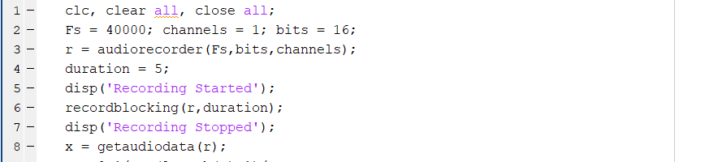

Fig 6. Audio signal

Fig 6. Shows the input signal that we took. It has a sampling frequency of 40000 and it records for 5 seconds.

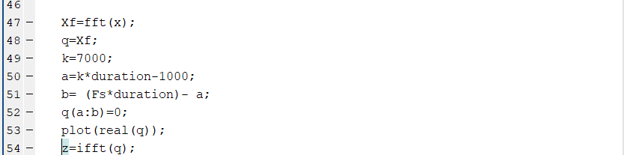

Fig 7. FFT part

Fig 7. Shows the transformation of the input signal into the FFT.

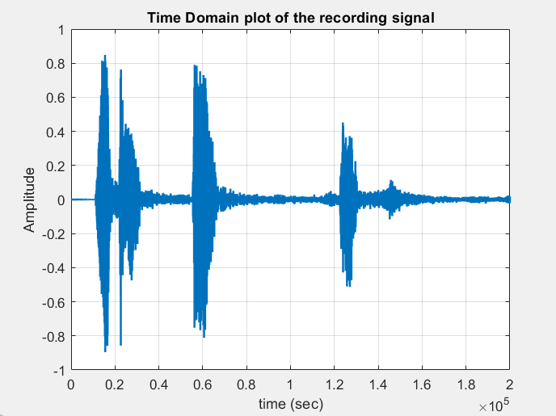

            Fig 8. Time domain signal

If we see the above figure fig 8. It is a time domain audio signal. That is recorded for 5 seconds with a sampling frequency of 40,000. The x axis represents the time in 200,000 samples (5 seconds * 40000 fs), And the y axis is the amplitude. We then convert the audio signal into frequency domain using FFT.

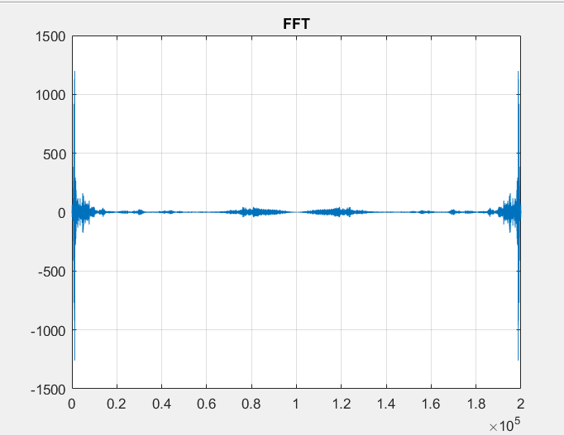

Fig 9. Frequency Domain signal

As you see it in the above figure, fig 9 the FFT will transform the time domain signal into frequency domain signal. The signal has a real and an imaginary part. That is why it looks the same from the same sides. The x axis represents the frequency in 200000 samples ,100000 for the real and 100000 for the imaginary part.

The real portion of an FFT result is how much each frequency component resembles a cosine wave, the imaginary component, how much each component resembles a sine wave. Various ratios of sine and cosine components together allow one to construct a sinusoid of any arbitrary or desired phase, thus allowing the FFT result to be complete.

# Result

Our work here is to eliminate frequencies that are above some level. Thanks to the FFT we did it easily. For example, let us try to eliminate frequencies above 7 kHz.

First an audio signal is recorded for 5 seconds. Then as Fig 7. Shows we convert the signal into frequency domain using FFT(Xf). Then we take the sample and using the code that is shown in Fig 5.  And remove both the imaginary and the real part from the sample. After we do that we then convert the signal into a time domain using IFFT (inverse FFT).

The output is shown in Fig 10. The first one shows the sample with a frequency of 10000 kHz. And the second one is the one after we remove the frequency above 7 kHz.

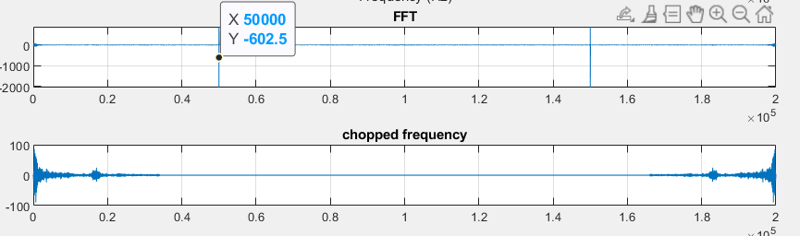

Fig 10. The output

## Remaining Work

* Model Implementation
* Hardware implementation
* Increasing the features of our project, like wind suppression and feedback suppression

# References

|  |  |
| --- | --- |
| [1] | W. H. Organization, "WHO," [Online]. Available: https://www.who.int/news-room/fact-sheets/detail/deafness-and-hearing-loss. [Accessed 28 10 2021]. |
| [2] | "https://www.consumeraffairs.com/health/hearing-aid-cost," [Online]. |
| [3] | "https://www.healthyhearing.com/help/hearing-aids/types," [Online]. |
| [4] | "https://www.fda.gov/medical-devices/hearing-aids/types-hearing-aids," [Online]. |
| [5] | fda.gov, "fda.gov," [Online]. Available: https://www.fda.gov/medical-devices/hearing-aids/types-hearing-aids. [Accessed 28 10 2021]. |
| [6] | D. Crecraft and D. Gorham, " Electronics, 2nd Ed," in *Electronics, 2nd Ed*, CRC Press, 2003, p. 168. |
| [7] | "https://www.pjrc.com/store/teensy40.html," [Online]. |
| [8] | "https://www.mathworks.com/products/matlab," [Online]. |